**Analyzing the Impact of Sabermetric on Team & Manager Success**

**Total Wins**

The team manager is not unlike a coach in other sports, they have the responsibility of calling the shots in the games. With the rise of sabermetrics, it raises the question of the true value that a manager brings to a team. If statistical analysis is guiding how a team should play, what value does a manager add? The following chart summarizes the running total of career wins by team manager, regardless of the team, while highlighting the top ten managers by total career wins.

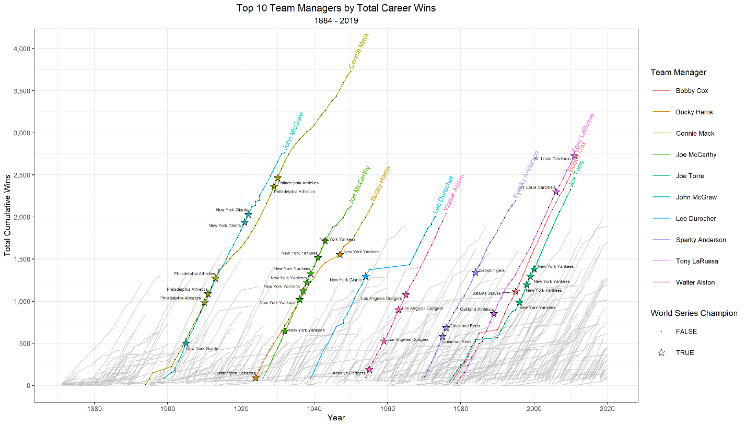

The data begins in 1876 and goes through 2019. Connie Mack leads the field in total wins over his long career with the Philadelphia Athletics. Three of the top 10 ended their careers in 2005 without any apparent change to the slope, or rate of wins per year, as the game shifted towards sabermetric methodology. Because sabermetric theory began with Bill James in the 1970s, the same decade that LaRussa, Cox, and Torre began their careers, they may have worked in tandem with the analytics to bring their success. However, Sparky Anderson began his career before sabermetrics and would have witnessed the sabermetric revolution first-hand. It does appear that his wins rate does taper off at the end of his career which could go as the old idiom says, “you can’t teach an old dog new tricks.” Huge assumption as numerous other factors could come into play, but this could indicate that managers who work with the analytics still provide value in the Moneyball era while those who resist are a net cost to the team. Another observation to note is the number of managers with total career wins greater than 1,000 does seem to be increasing in the Moneyball era.

Looking at this from another perspective, the chart below gives the same information but highlights the top ten managers by their average wins per season, or those with the steepest slope. This gives the benefit of controlling for the duration of a manager’s career. Under this spotlight, only one of the top ten, Mike Scioscia, was able to have sustained success over numerous seasons during the Moneyball era. Although Larry Dierker did make the top ten over five seasons in the era of sabermetrics. Comparing the Moneyball era to the earlier periods, it does become apparent that prolonged success is more difficult with the introduction of sabermetrics which could indicate the lack of correlation of a team manager on success.

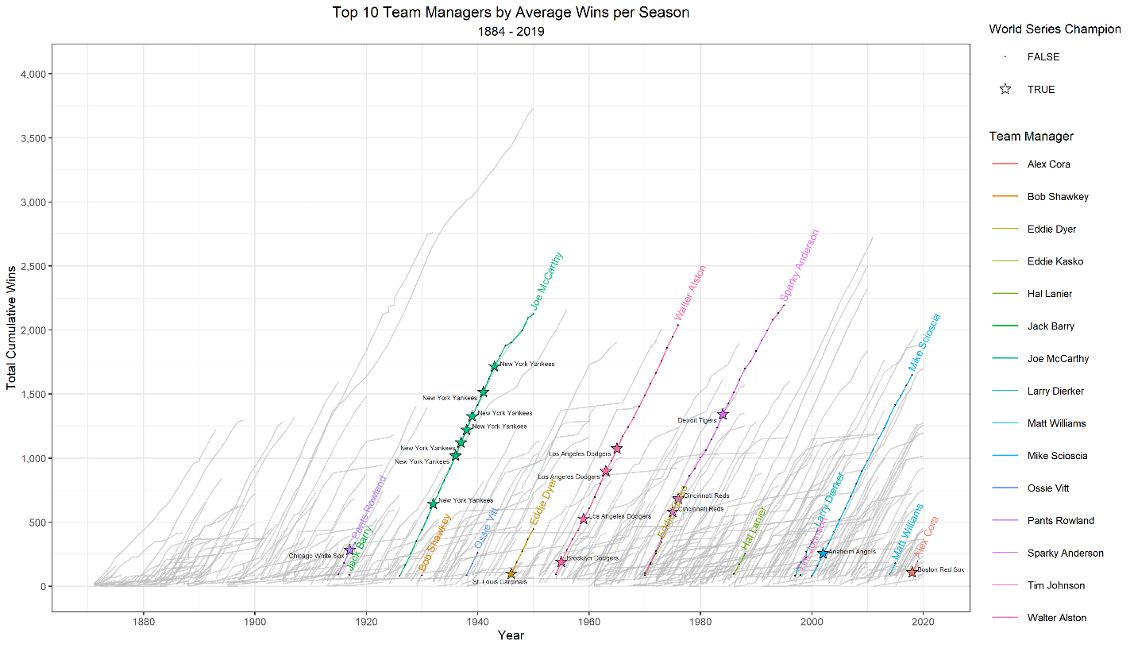

**World Series Championships**

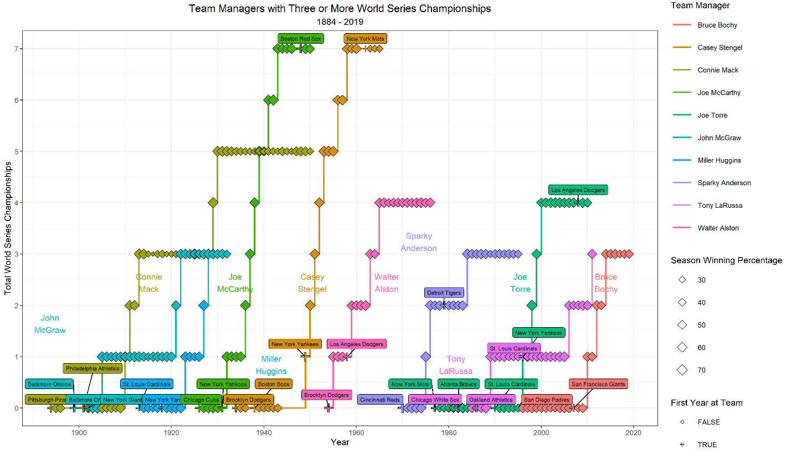Success can also be viewed as the number of wins of the pinnacle game of each season: the World Series Championship. The chart below shows the team managers with three or more World Series championships throughout their careers and the team that they were with for that championship. A fact to consider is that most of these wins did occur with the New York Yankees. To go along with that, only two managers were able to win a championship with more than one team. This is despite Joe McCarthy and Casey Stengel winning seven championships each then finishing their careers with multiple seasons on different teams and unable to seal the deal. This calls to question whether it is the manager leading to this success or if the given franchise is the leading factor.

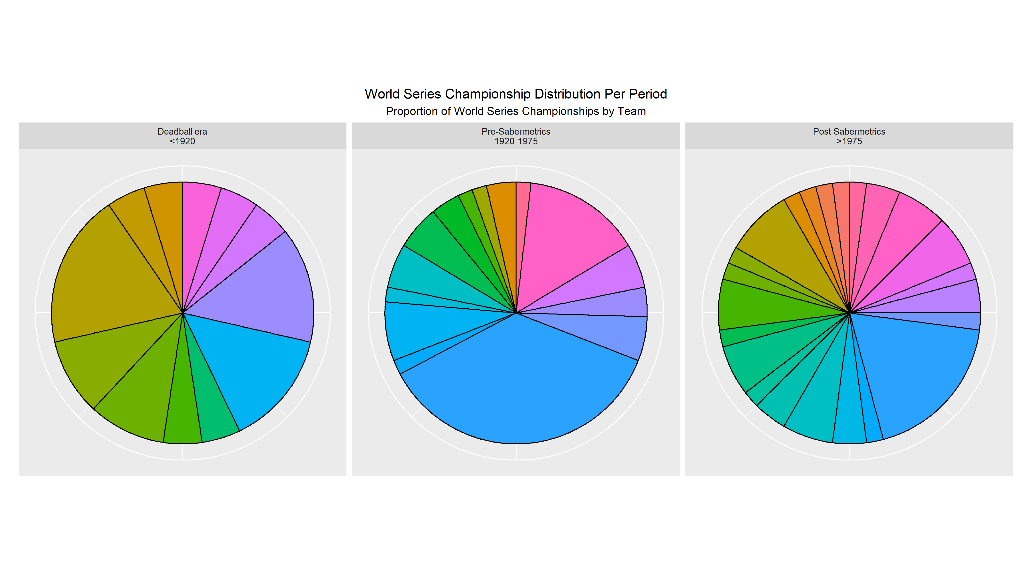 The chart below displays the proportion of World Series Championships by teams for each period: the Deadball era, pre-Sabermetric era, and the Sabermetric era. The size relates to the percent of championships won and each color represents a different team. As sabermetrics allowed teams to better target their dollars for results, this should increase the odds of lower-funded teams winning the championship which is why the sabermetric-era pie chart shows far more teams. The Yankees with their large budget dominated the pre-sabermetric era, as represented by the large blue chunk, but did not maintain this level of success with the rise of analytics.

However, despite the decrease in proportion of World Series championships, the Yankees were the team with the highest Winning Percentage in each era of modern baseball. This is despite, as seen in the chart below, the top 10 teams per era by winning percentage changed drastically. A notable inclusion in the top ten during the Moneyball period are the Oakland Athletics who used sabermetrics to compete with higher-funded teams for a fraction of the cost.

